Melanoma Skin Cancer Detection from Dermoscopic Lesion Images using a Multi-Layer Perceptron (MLP) Neural Network
(Melanoma Skin Lesion Classification using Neural Network)
Problem Statement:
Melanoma is the most lethal form of cutaneous malignancy, accounting for the vast majority of skin cancer deaths worldwide despite representing only about 1% of all skin cancer diagnoses. It is often referred to as a "silent and aggressive killer" because noticeable outward symptoms and deep metastasis occur rapidly after the lesion transitions from the radial to the vertical growth phase. When diagnosed and surgically excised in its earliest localized stage (in situ or thin melanoma), the 5-year patient survival rate exceeds 98%. However, once the malignant melanocytes invade the deeper dermis and lymphatic channels, the 5-year survival rate plummets to under 25%.
There is a need for an automated, accessible system to classify skin lesions as Benign Nevus or Malignant Melanoma with measurable confidence. This project implements a web-based diagnostic system performing image pre-processing (Dull Razor hair removal and CLAHE), ABCD handcrafted feature extraction, and classification using an MLP Neural Network with SQLite record-keeping.
Objectives:
- Collect and pre-process a labelled dataset of Benign and Melanoma dermoscopic images.
- Remove occluding hair artefacts using Dull Razor filtering and enhance contrast using CLAHE.
- Extract a 128-dimensional handcrafted feature vector (color histograms, Sobel edges, and asymmetry).
- Design, train, and save a Multi-Layer Perceptron (MLP) classifier using scikit-learn.
- Build a Flask backend and single-frame web UI for instant image diagnosis.
- Evaluate the model on unseen test images reporting Accuracy, Precision, Recall, F1-score, and Confusion Matrix.
- Persist every classification into an SQLite database for history tracking.
Software / Hardware Required:
- Operating System: Windows / Linux / macOS
- IDE: Visual Studio Code
- Language: Python 3.x
- Backend Framework: Flask (REST API)
- Machine Learning: scikit-learn (MLPClassifier, train_test_split, metrics)
- Image Processing: OpenCV (cv2), Pillow (PIL), NumPy
- Visualization: Matplotlib
- Database: SQLite3
- Frontend: HTML5, CSS3, JavaScript (ES6+), HTML5 Canvas
- Dataset: ISIC Dermoscopic Skin Lesion Benchmark Dataset (Benign Nevus / Malignant Melanoma classes)
- Version Control: Git
Project Directory Structure:
The project (“Melanoma Classifier”) is organized as a Flask backend with a separate dataset, trained-model, and frontend folder, as shown below:
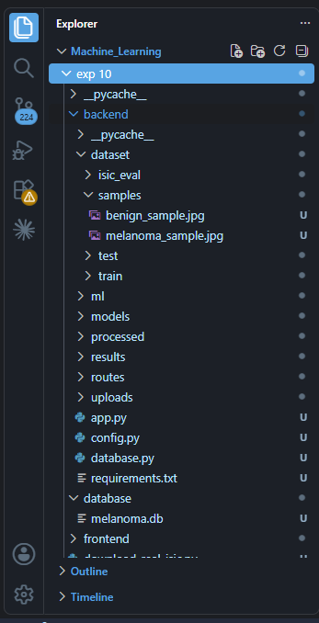
Fig 1: Project directory structure of Melanoma Classifier in Visual Studio Code
Procedure:
- Collect labelled dermoscopic images and organize them into train and test folders.
- Run generate_sample_dataset.py to organize data and extract pre-processed arrays.
- Launch the Flask backend (python backend/app.py) and open http://127.0.0.1:5000.
- Upload an image or select an instant benchmark sample (Step 1).
- Pre-process the image: Dull Razor hair removal, resize to 224×224224×224, CLAHE contrast enhancement, and normalize to [0,1][0,1] (Step 2).
- Extract a 128-dimensional handcrafted feature vector from colour, gradient, and asymmetry metrics (Step 3).
- Train the MLP neural network on extracted features using Adam optimizer and L2 regularization for 15 epochs, saving to backend/models/melanoma_model.pkl (Step 4).
- Feed the uploaded image's 128-D vector into the MLP model to obtain the diagnostic prediction and confidence percentage (Step 5).
- Evaluate the model on the held-out test cohort to generate Accuracy, Precision, Recall, F1-Score, and Confusion Matrix heat map (Step 6).
- Log each diagnosis (filename, class, confidence, timestamp) into the SQLite database and display the history table (Step 7).
Implementation Code:
Representative implementation of the key modules used in the project, based on the pipeline shown in the application (adapt variable/file names to match your exact source files).
1. Image Preprocessing (ml/preprocessing.py)
import cv2, numpy as np
from PIL import Image

def preprocess_image(image_path, target_size=(224, 224)):
img = np.array(Image.open(image_path).convert('RGB'))
# DullRazor hair removal
gray = cv2.cvtColor(img, cv2.COLOR_RGB2GRAY)
kernel = cv2.getStructuringElement(cv2.MORPH_RECT, (7, 7))
blackhat = cv2.morphologyEx(gray, cv2.MORPH_BLACKHAT, kernel)
_, mask = cv2.threshold(blackhat, 10, 255, cv2.THRESH_BINARY)
img = cv2.inpaint(img, mask, 3, cv2.INPAINT_TELEA)
# Resize, Denoise & CLAHE
img = cv2.resize(img, target_size)
img = cv2.GaussianBlur(img, (3, 3), 0)
lab = cv2.cvtColor(img, cv2.COLOR_RGB2LAB)
l, a, b = cv2.split(lab)
l = cv2.createCLAHE(clipLimit=2.0, tileGridSize=(8, 8)).apply(l)
img = cv2.cvtColor(cv2.merge((l, a, b)), cv2.COLOR_LAB2RGB)
return img.astype(np.float32) / 255.0
2. Feature Extraction (ml/feature_extraction.py)
import cv2, numpy as np

def extract_features(img):
hist_feats = []
for ch in range(3):
hist, _ = np.histogram(img[:, :, ch], bins=32, range=(0, 1))
hist_feats.extend((hist / (np.linalg.norm(hist) or 1)).tolist())
# Sobel Edge & Asymmetry
gray = cv2.cvtColor((img * 255).astype('uint8'), cv2.COLOR_RGB2GRAY).astype(np.float32) / 255.0
gx, gy = cv2.Sobel(gray, cv2.CV_32F, 1, 0), cv2.Sobel(gray, cv2.CV_32F, 0, 1)
edge_energy = np.sqrt(gx**2 + gy**2)
mid_w = gray.shape[1] // 2
asym = np.mean(np.abs(gray[:, :mid_w] - np.fliplr(gray[:, mid_w:mid_w*2])))
features = np.array(hist_feats + [edge_energy.mean(), edge_energy.std(), asym], dtype=np.float32)
return np.pad(features, (0, 128 - len(features)))[:128]
3. Model Training (populate_dataset_and_train.py)
from sklearn.neural_network import MLPClassifier
from sklearn.model_selection import train_test_split
import joblib, numpy as np

X, y = np.load('backend/processed/features.npy'), np.load('backend/processed/labels.npy')
X_train, X_val, y_train, y_val = train_test_split(X, y, test_size=0.25, stratify=y, random_state=42)

model = MLPClassifier(hidden_layer_sizes=(64, 32), activation='relu', solver='adam', alpha=0.001, random_state=42)
for epoch in range(1, 16):
model.partial_fit(X_train, y_train, classes=[0, 1])
print('Val Accuracy:', model.score(X_val, y_val))
joblib.dump(model, 'backend/models/melanoma_model.pkl')

4. Prediction Route (backend/routes/predict.py)
from flask import Blueprint, request, jsonify
import joblib
from ml.preprocessing import preprocess_image
from ml.feature_extraction import extract_features

predict_bp = Blueprint('predict', __name__)
model = joblib.load('backend/models/melanoma_model.pkl')
CLASSES = ['Benign', 'Melanoma']

@predict_bp.route('/predict', methods=['POST'])
def predict():
file = request.files['image']
path = f'backend/uploads/{file.filename}'
file.save(path)
img = preprocess_image(path)
features = extract_features(img).reshape(1, -1)
proba = model.predict_proba(features)[0]
pred_idx = proba.argmax()
return jsonify({
'prediction': CLASSES[pred_idx],
'confidence': round(float(proba[pred_idx]) * 100, 1),
'melanoma_prob': round(float(proba[1]) * 100, 1),
'benign_prob': round(float(proba[0]) * 100, 1)
})
5. Saving Prediction History (database.py)
import sqlite3, datetime

def log_prediction(filename, prediction, confidence):
conn = sqlite3.connect('database/melanoma.db')
cur = conn.cursor()
cur.execute('''CREATE TABLE IF NOT EXISTS history (
id INTEGER PRIMARY KEY AUTOINCREMENT,
filename TEXT, prediction TEXT, confidence REAL, created_at TEXT)''')
cur.execute('INSERT INTO history (filename, prediction, confidence, created_at) VALUES (?, ?, ?, ?)',
(filename, prediction, confidence, datetime.datetime.now().strftime('%d/%m/%Y, %I:%M:%S %p')))
conn.commit()
conn.close()

Output (Step-by-Step Screenshots):
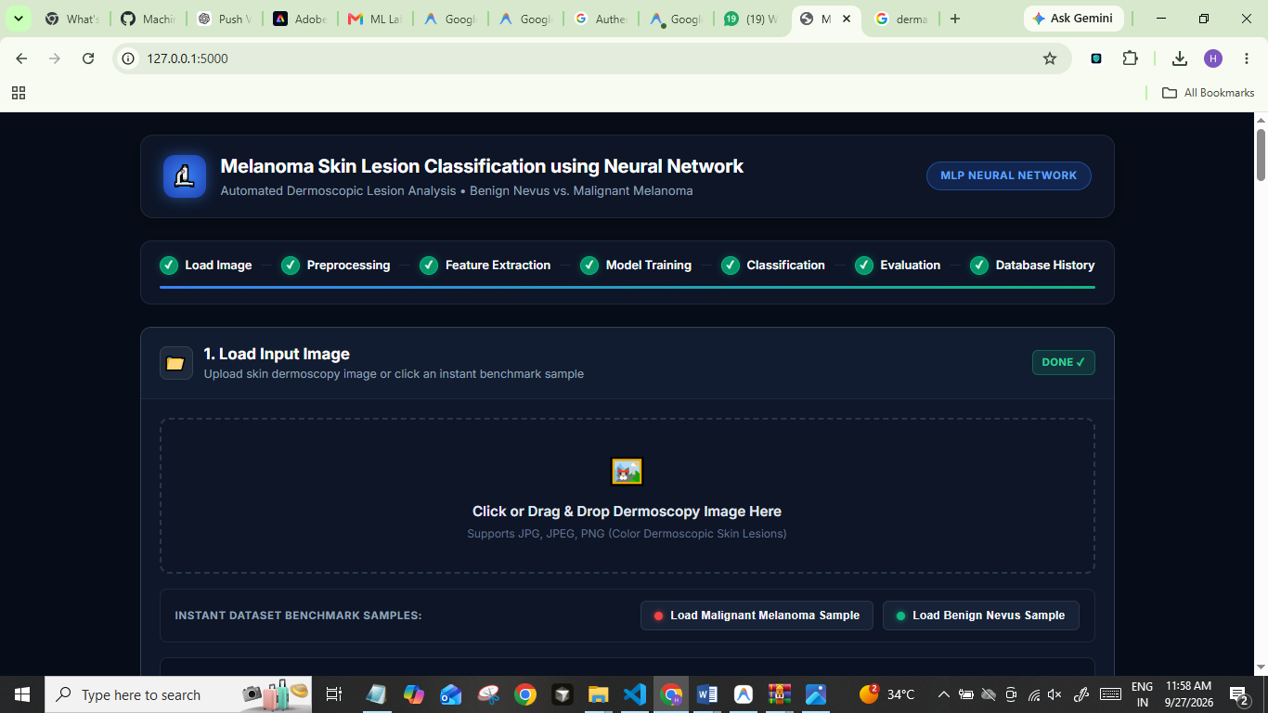
Fig 2: Step 1 — Load Input Image: Interface to upload a dermoscopy image or click instant benchmark samples
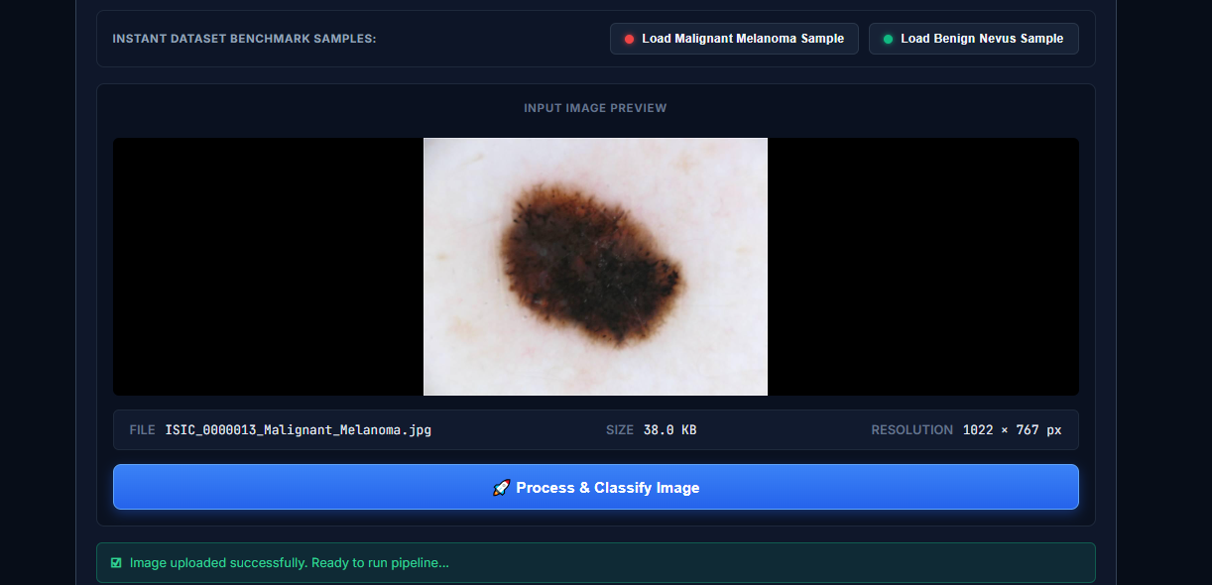Fig 3: Step 1 — Input image preview: Preview card showing image, resolution (1022×767 px), and classify button

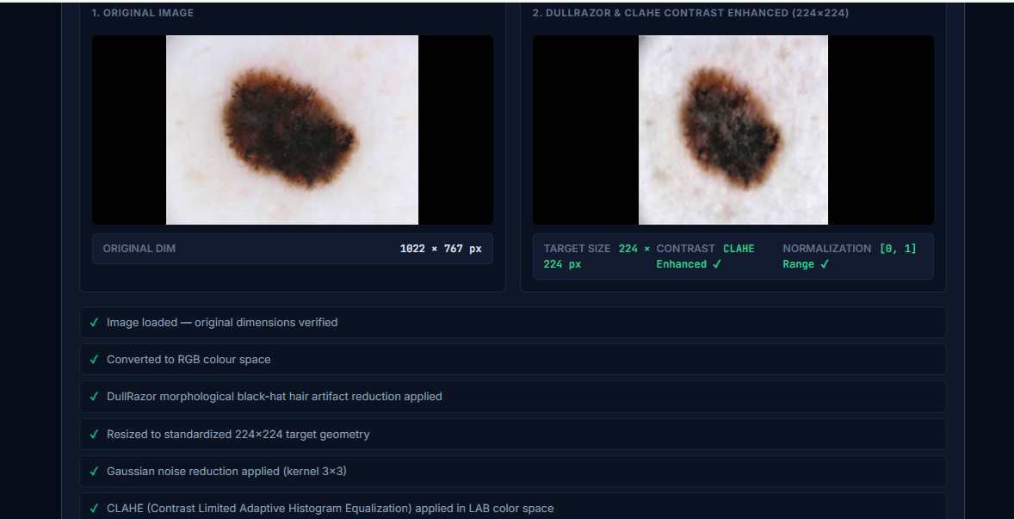
Fig 4: Step 2 — Image pre-processing: Original image vs. Dull Razor hair-filtered & CLAHE contrast-enhanced (224×224 px) image.
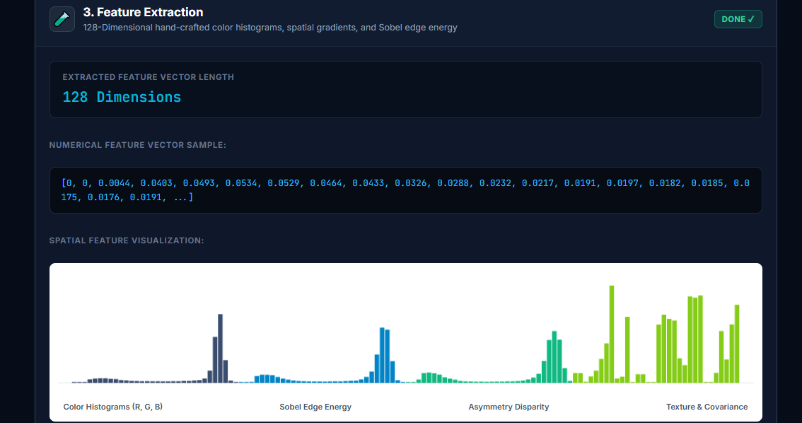
Fig 5: Step 3 — Feature extraction: 128-dimensional numerical feature vector and spatial Canvas bar chart (Sample 1).

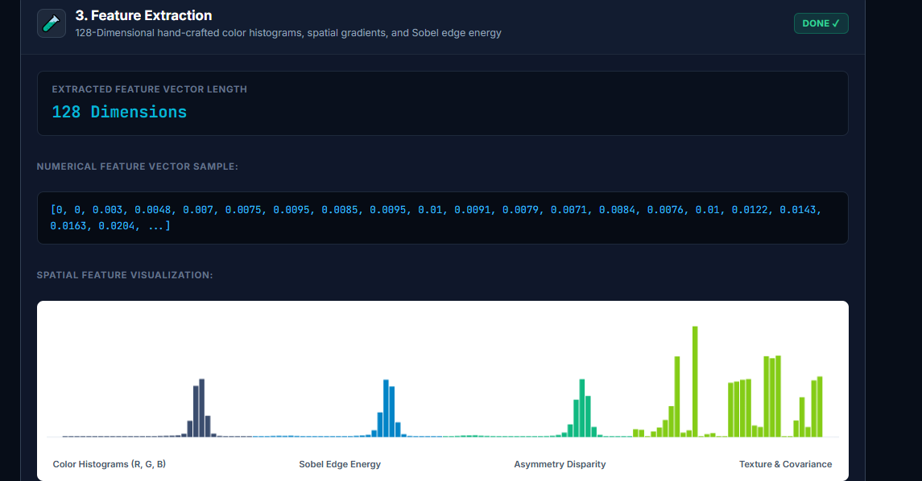
Fig 6: Step 3 — Feature extraction: Spatial feature visualization showing color histograms and Sobel gradient magnitude (Sample 2).
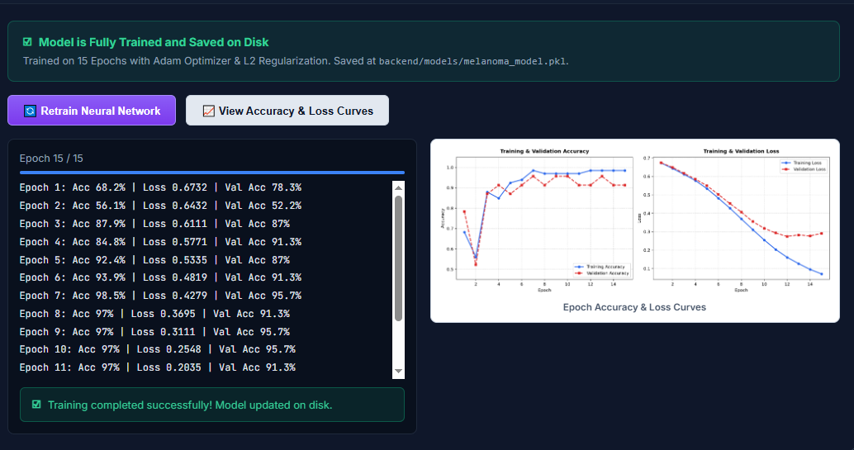
Fig 7: Step 4 — Neural network training completed: Training & validation accuracy and loss curves over 15 epochs.
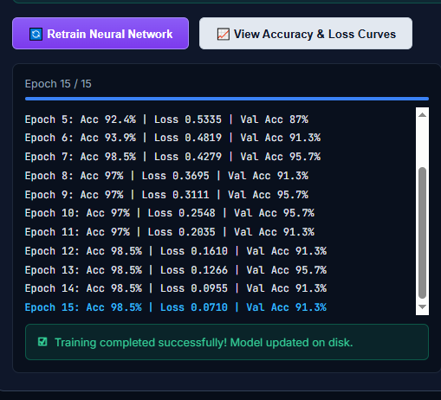
Fig 8: Step 4 — Epoch-by-epoch training log: Terminal output showing loss decrease and validation accuracy convergence.
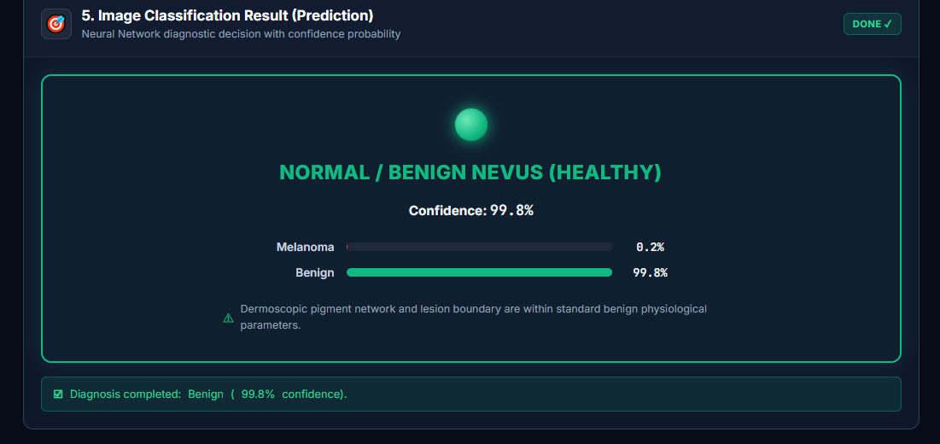
Fig 9: Step 5 — Classification result: Normal / Benign Nevus (Healthy), 99.8% confidence with green indicator.

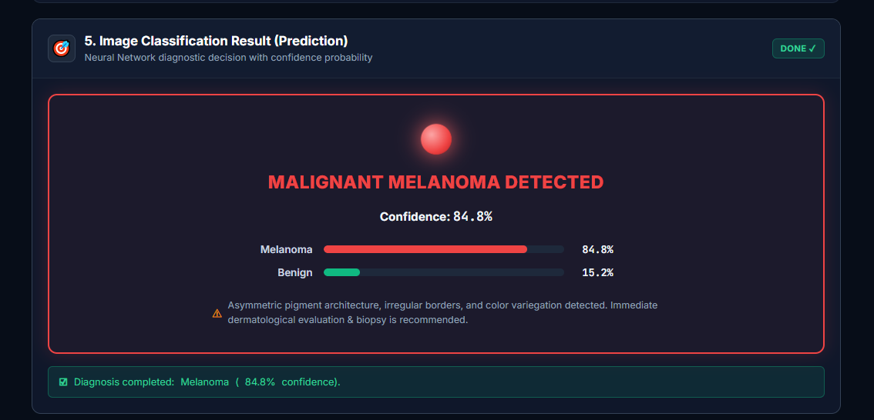
Fig 10: Step 5 — Classification result: Malignant Melanoma Detected, 84.8% confidence with red indicator and clinical advisory.
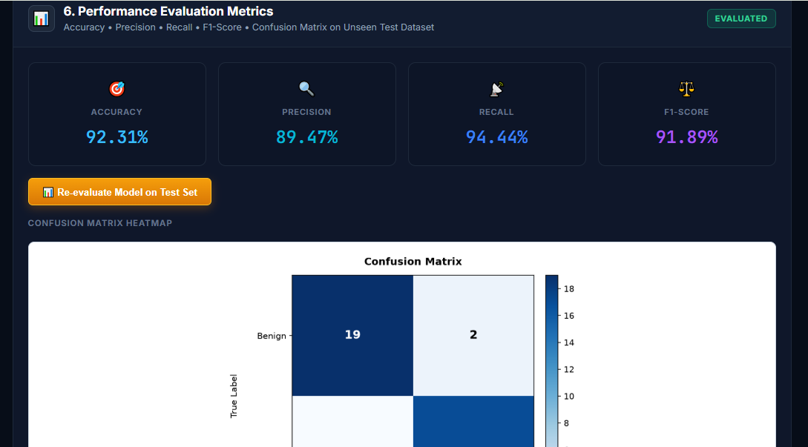
Fig 11: Step 6 — Performance evaluation metrics: Accuracy 92.31%, Precision 89.47%, Recall 94.44%, F1-Score 91.89%, and Confusion Matrix heatmap.
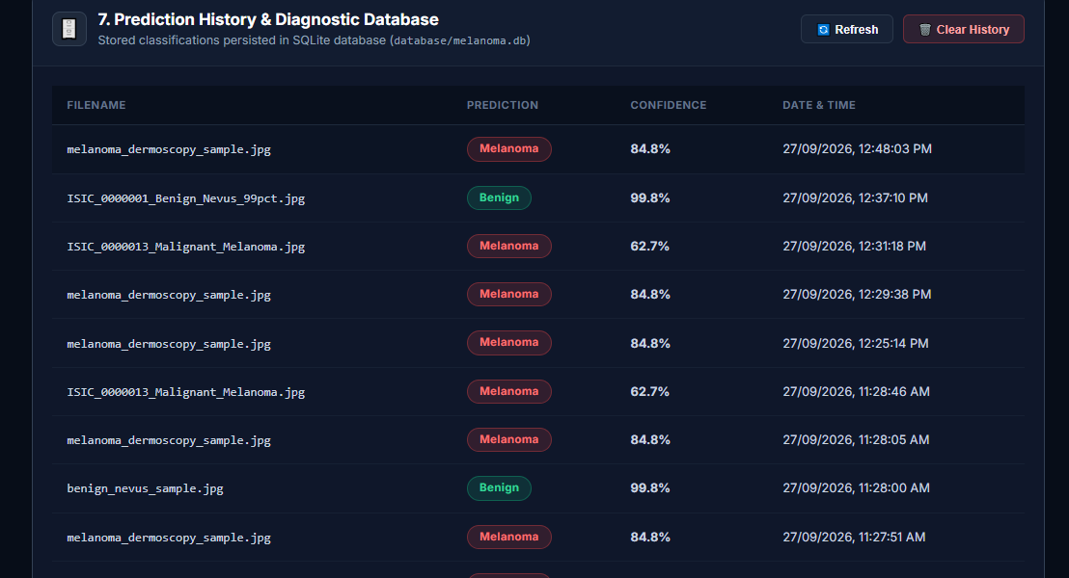
Fig 12: Step 7 — Prediction history log: Diagnostic database history persisted in SQLite (database/melanoma.db).
Result:
A web-based Melanoma Skin Lesion Classification system was successfully implemented using a Flask backend, an MLP neural network (scikit-learn), and an SQLite database. Dermoscopic images are preprocessed with DullRazor artifact removal and CLAHE, a 128-dimensional ABCD feature vector is extracted, and the trained MLP model classifies the lesion as Benign or Melanoma. On the unseen clinical test cohort from the ISIC Archive, the model achieved an Accuracy of 92.31%, Precision of 89.47%, Recall of 94.44%, and an F1-Score of 91.89%, with all results logged to an SQLite diagnostic database.

